**Web Design and Development Foundations with HTML5**

**Hands-On Practice (HOP)**

HOP 11.1

When you run the code in the browser:

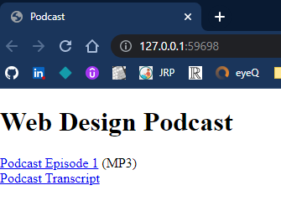

After you click "Podcast Episode 1":

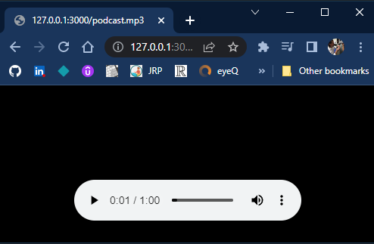

After you click "Podcast Transcript":

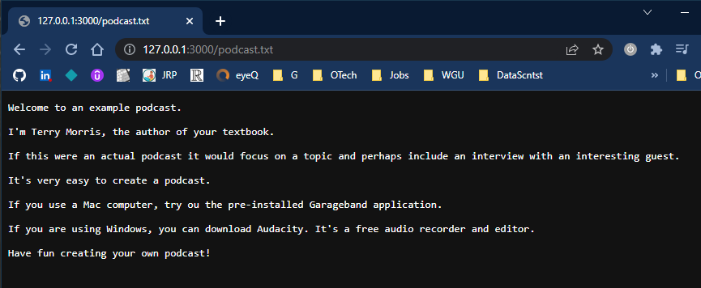

HOP 11.3

When you run the code in the browser:

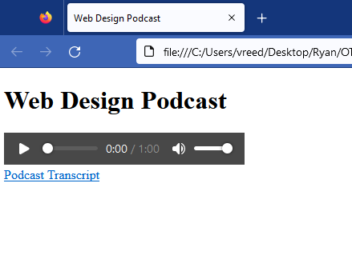

After you click "Podcast Transcript":

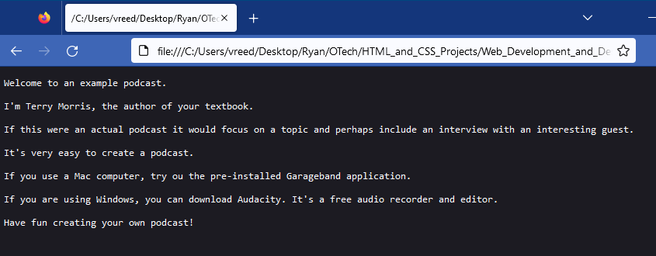

HOP 11.4

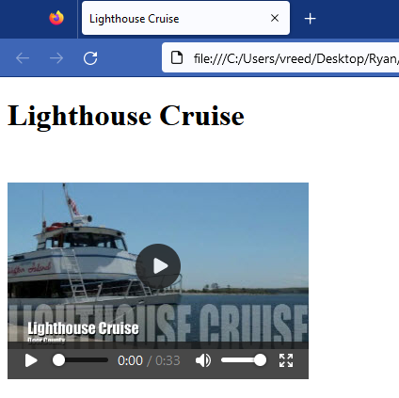

HOP 11.5

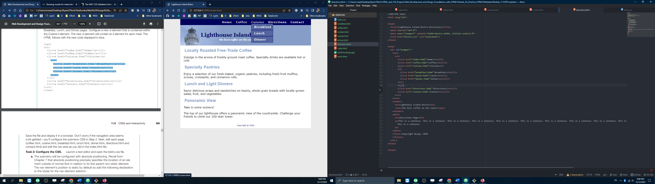

HOP 11.6

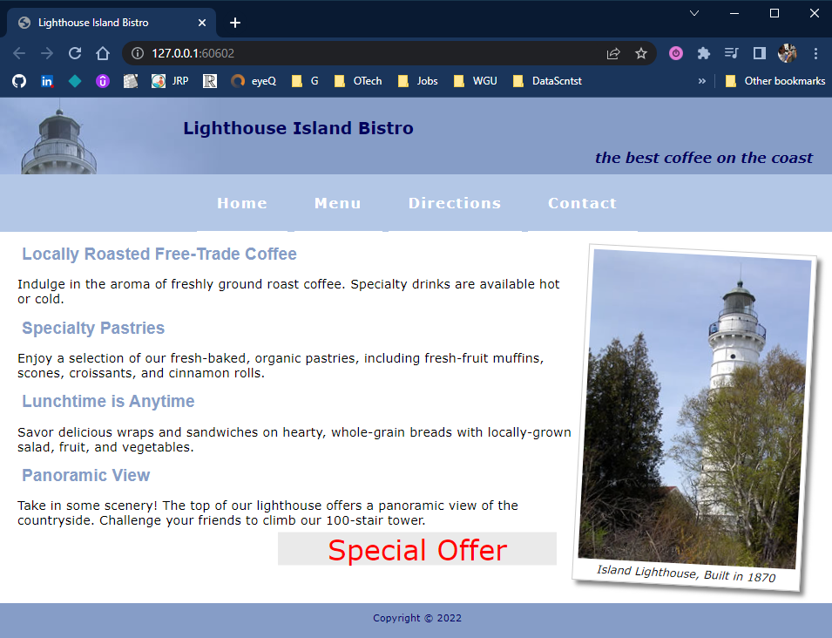

HOP 11.7



HOP 11.8



HOP 11.9

